

#### **A MINOR PROJECT REPORT ON**

#### (Tour and Tourism Guide)

**SUBMITTED BY:**

**SOUMYA RANJAN MAHANTA (2205298175)**

**TEJASKAR MAHANTA (2205298211)**

**UNDER THE GUIDANCE OF**

**Mrs.SMRUTI SMARAKI SARANGI**

**Professor**

**GIFT COLLEGE, BBSR**



**DEPARTMENT OF MASTER IN COMPUTER APPLICATION**

**GANDHI INSTITUTE FOR TECHNOLOGY (AUTONOMOUS)**

**BHUBANESWAR-752054**

CERTIFICATE

This is Certify that Mr. **SOUMYA RANJAN MAHANTA (2205298175)** &Mr. **TEJASKAR MAHANTA (2205298211)** under to this project using HTML,CSS,JS in the 2ND semester. In this project we have completed all steps or phases of assigned projects for the partial fulfilment of requirement for the degree of master in computer application from Gandhi Institute for Technology.

**Mr. Pratyush Ranjan Mohapatra External Examiner Guide Sign**

**Head of the Department**

**GIFT, Bhubaneswar**

DECLARATION

We Mr. Tejaskar Mahanta & Mr. Soumya Ranjan Mahanta, student of MCA ,GIFT BBSR hereby declare that the project report has been done by under the guidance of Mrs. **SMRUTI SMARAKI SARANGI** , Project Guide, GIFT, BHUBANESWAR for the partial requirement for the Degree in MCA.

This project submitted by us is the effort of ours and has not been deposited to any other organization or published earlier.

Place:-Bhubaneswar TEJASKAR MAHANTA (2205298211)

Date:- SOUMYA RANJAN MAHANTA (2205298175)

#### ACKNOWLEDGEMENT

We are grateful to Mrs. **SMRUTI SMARAKI SARANGI**

, Project Guide, GIFT, Bhubaneswar for assigning us this innovation project and modelling us both technically and morally for achieving greater success in life.

It is great senses of satisfaction that our first real live venture in practical computing is in the form of project work. We extend our humble obligation towards Mr. Pratyush Ranjan Mohapatra, H.O.D, Dept of MCA, center for post Graduate studies, GIFT for providing us with an environment to study and build our career.

Above all we thank the almighty without whose grace and blessings I would not have been able to complete my work successfully.

Soumya ranjan Mahnata

Tejaskar Mahanta

ABSTRACT

The Travel and Tourism Management System is a web based application and maintains a centralized repository of all related information. The objective of this project is to develop a system that automates the processes and activities of a travel agency. The purpose is to design a system using which one can perform all operations related to traveling and sight-seeing. In the present system a customer has to approach various agencies to find details of places and to book tickets. This often requires a lot of time and effort. A customer may not get the desired information from these offices and often the customer may be misguided. It is tedious for a customer to plan a particular journey and have it executed properly

CONTENTS

#### Introduction

#### Aim of the project

#### Software requirement

#### Objectives

#### Features

#### Advantages

#### CONCLUSION

#### Future scope

INTODUCTION

Tourism has turned out to be an economic booster contributing to the economic development of many countries over the last few decades. People see holidays as a necessity, and not as luxury in the present scenario. Tourism calls for coordination and cooperation between travel agents, tour operators, and tourists. Tourism has a few major elements − destinations, attractions, sites, accommodation, and all ancillary services. The need for a robust and dynamic tour management application has been around since the advent of the tourism concept. Thus we have developed an application to provide the best travelling services to the customers and travel agents. The Tourism Management System provides a search platform where a tourist can find their tour places according to their choices. This system also helps to promote responsible and interesting tourism so that people can enjoy their holidays at their favorable places and develop tourism with different cultures so that they enrich the tourism experience and build pride. The Tourism Management System is a web based application. The objective of this project is to develop a system that automates the processes and activities of a travel agency. It is tedious for a customer to plan a particular journey and have it executed properly. This project is developed to replace the currently existing system, which helps in keeping records of the customer details of destination as well as payment received. The proposed system is highly automated and makes the travelling activities much easier and flexible. The users can get the very right information at the very right time. This will increase the trust of the customer into the tourism company as well. This project is designed with SQL Server as back end. All the data will be stored in the server and in case of any data losing situation, a backup will be available by this server. The details related to every aspect of the tourist will be available separately. The admins just have to click once and all the details will be available to them.

AIM OF THE PROJECT

The main purpose of "Travel at Glance" is to provide an alternate and convenient way for a customer to book hotels, flight, train and bus for tour purposes. In this project, we aim to choose that particular experience which will shape vision of the country by visiting our website. We will make an easier task of searching places and for booking train, flight or bus. We provide a Judgment and approach skills to critically examine how a tourist visits and its ability to operate in an appropriate way when dealing with the consequences of tourism, locally, regionally, and nationally including visitor security and ecological influences.

Requirement Specification

**Software Requirements**

* HTML :- HTML stands for HyperText Markup Language. It is used to design web pages using the markup language.
* CSS :- CSS stands for Cascading Style Sheets, and it’s used to add style to a web page by dictating how a site is displayed on a browser.
* JavaScript
* React
* Node js with Npm Dependencies

**Hardware Requirements**

PROCESSOR: Intel® Celeron® Processor 847, 1.10 GHz, or equivalent

STORAGE: Between 1.3 GB - 2.3 GB

RAM: Minimum of 512 MB.

The recommended amount can vary depending on the number of users connected and other factors.

HARD DISK: 3 GB of available hard-disk space for installation, additional free space is required during installation

OBJECTIVES

The Project encompasses several key objectives that drive its overall mission of revolutionizing the retail industry. These objectives include:

1. To develop a web based application which includes
2. To provide best travelling services to the customers and travel agents.
3. To provide a search platform where a tourist can find their tour places according to their choices.
4. To promote responsible and interesting tourism so that people can enjoy their holidays at their favorable places.
5. To develop tourism with different cultures so that they enrich the tourism experience and build pride.
6. To create and promote forms of tourism that provide healthy interaction opportunities for tourists and locals and increase better understanding of different cultures, customs, lifestyles, traditional knowledge and believes.
7. To provide a better way to connect with various events.

**Architecture Design**

Outline Of The Project: -

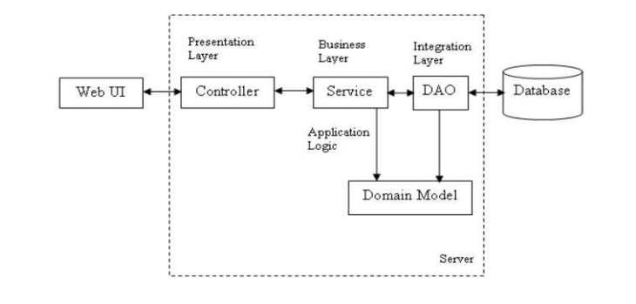

The whole software design can be divided mainly into 3 parts - WebUI, a middleware layer and a persistence layer. This project is developed for a tourism manager where he is able to add new tourists, update/delete the tourist details. It also has a search module where the assistant can search the tourist names based on their from and to location.

**Technology across different layers:**

|  |  |
| --- | --- |
| **Technology Layer** | **Category** |
| Presentation Layer / Web UI | HTML5,CSS 3, JavaScript, React, ReactStrap UI components etc. |
| Middleware Layer | Node js and NPM Dependecies |
| Persistence Provider | Hibernate with MongoDB database |

**Relational Database Schema: -**

The data is stored in a database that is developed in MySQL. The database consists of two tables. Data of a tourist means details such as ID, name, from location, to location, no. of days and the price of tour package with ID as the primary key which is placed in a table tourpackage. The user table has the data like username and password for login that enables the admin to manipulate the information regarding each tourist.

**EER Diagram Of Project: -**

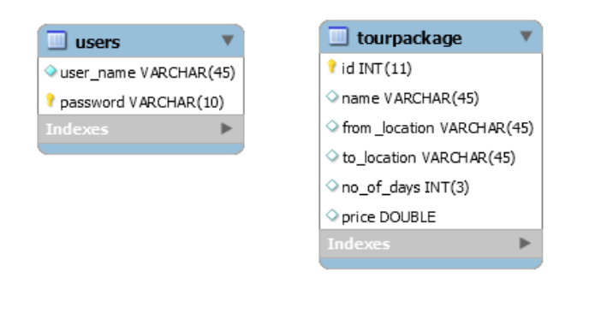

**Snapshot: -**

HOME page

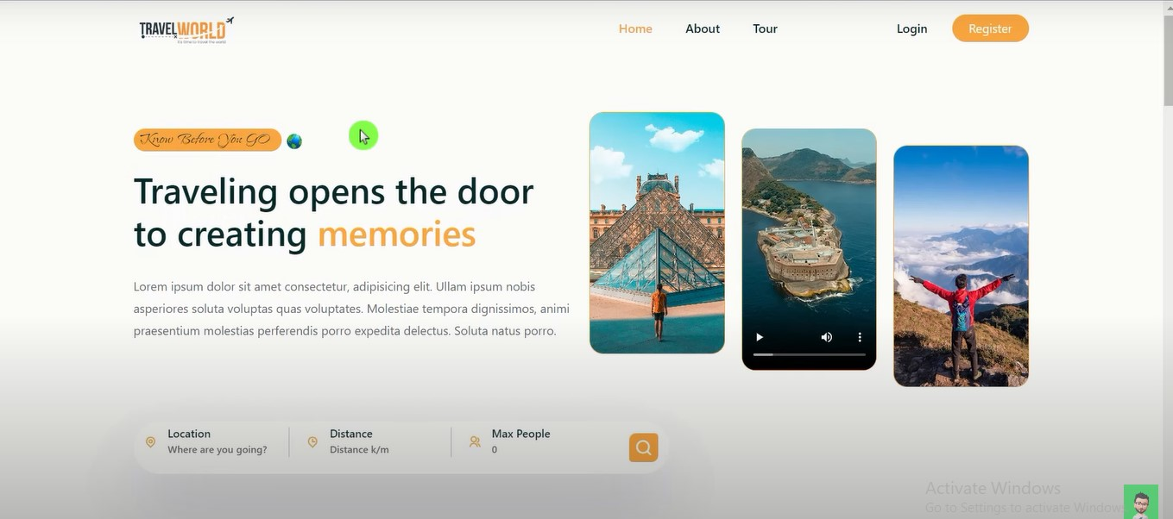

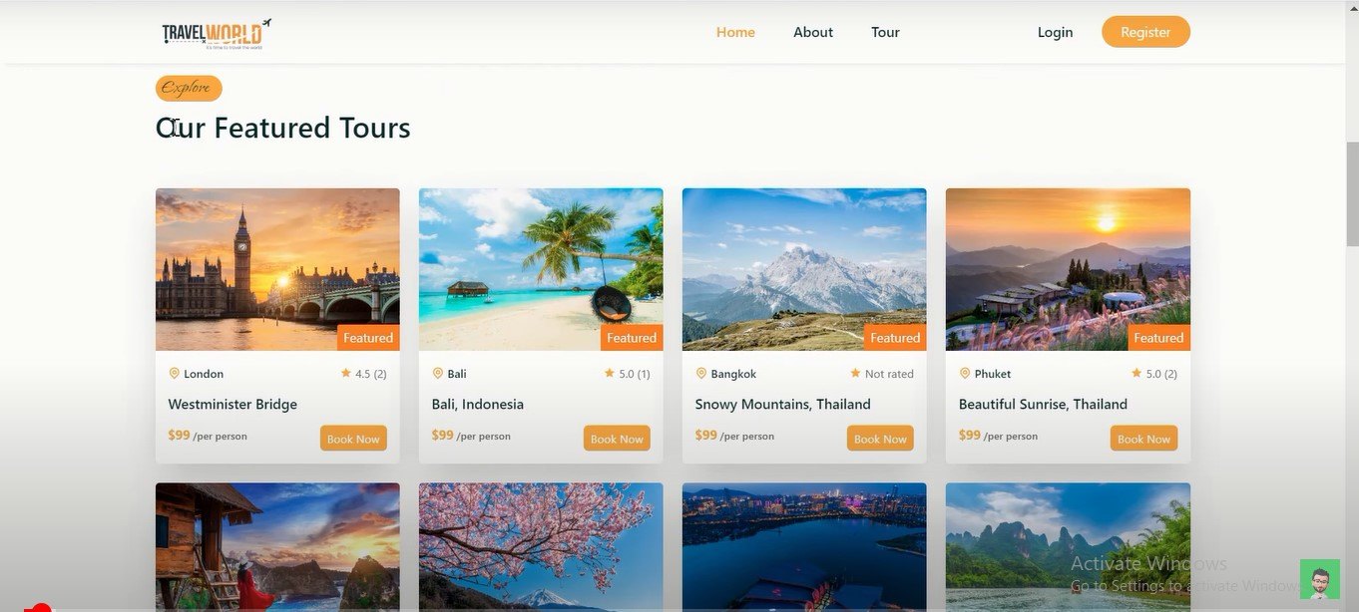

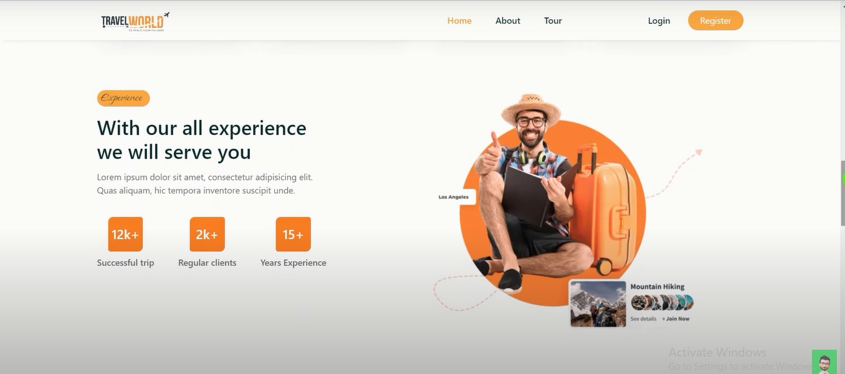

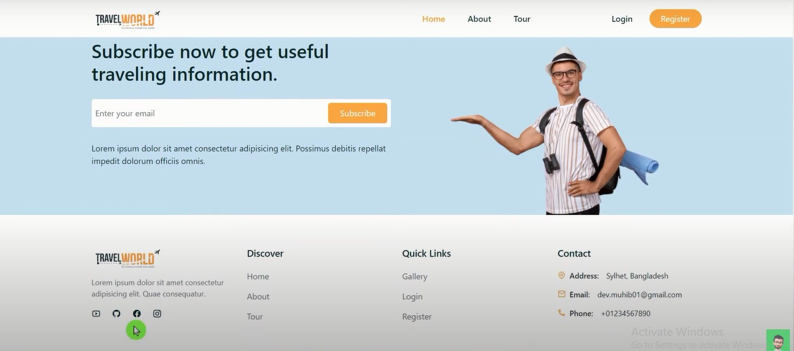

**Login and Register:-**

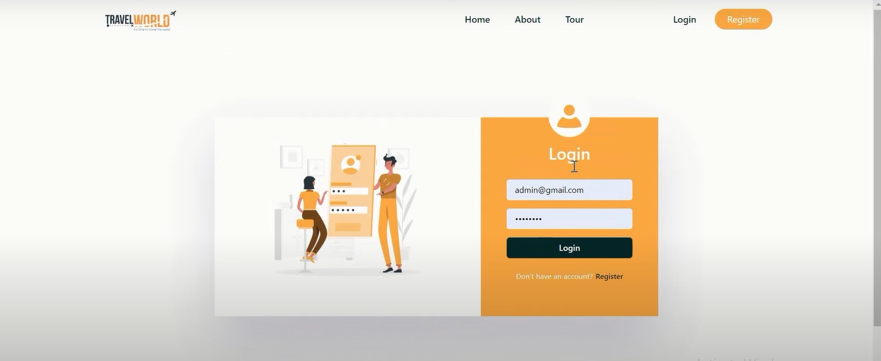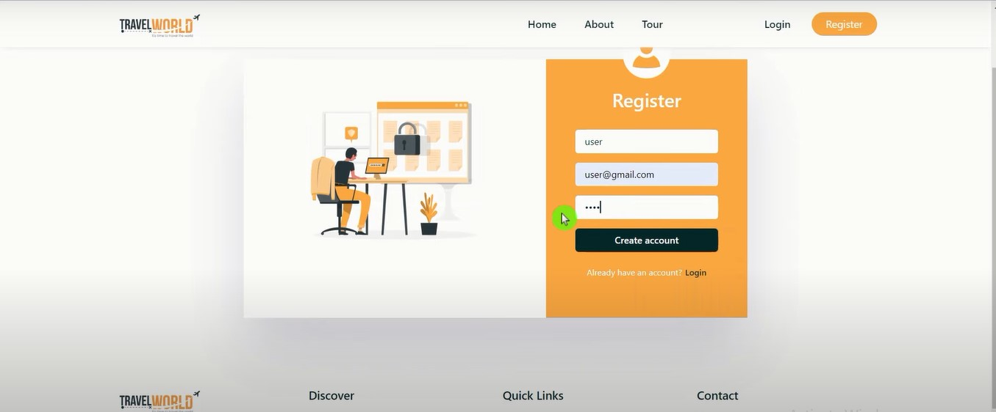

**Tour page:-**

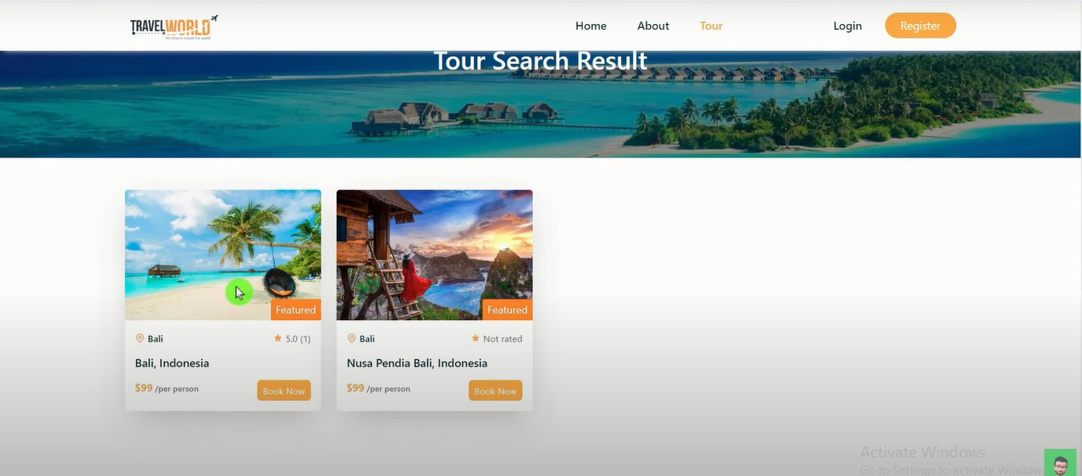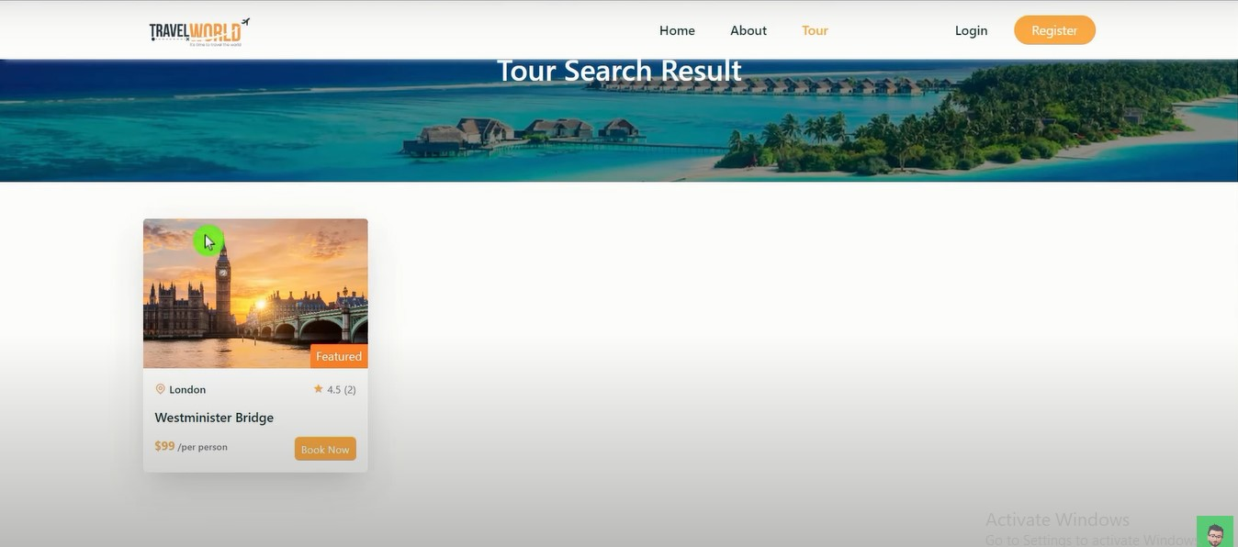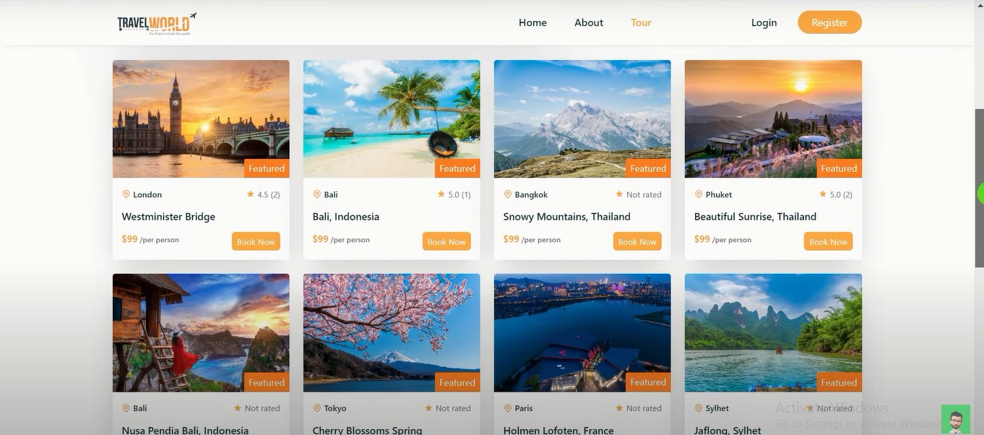

**Destination and Review: -**

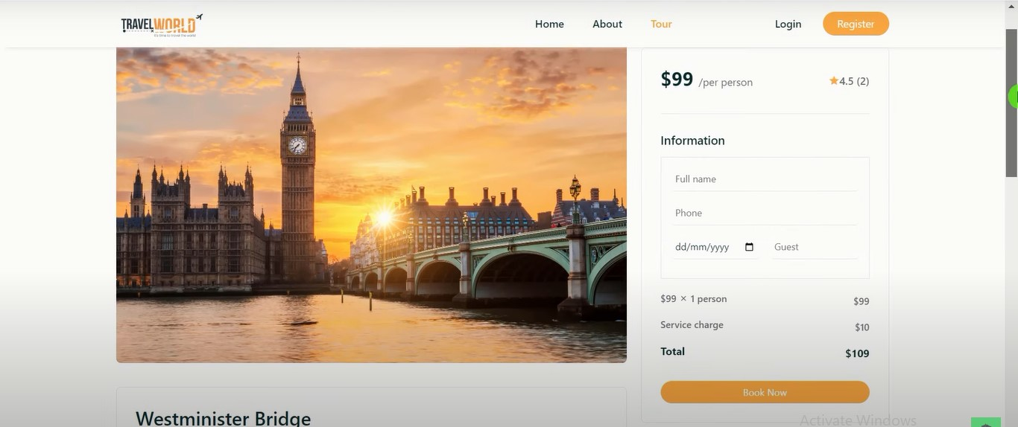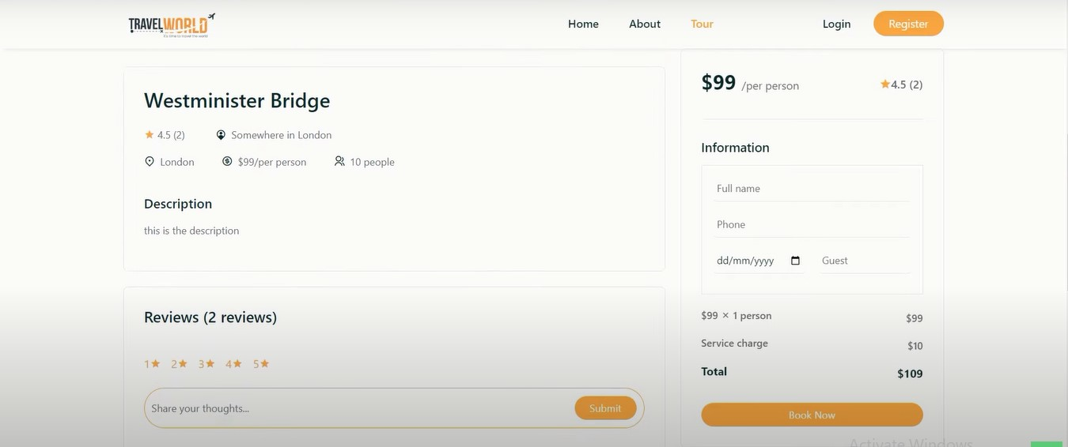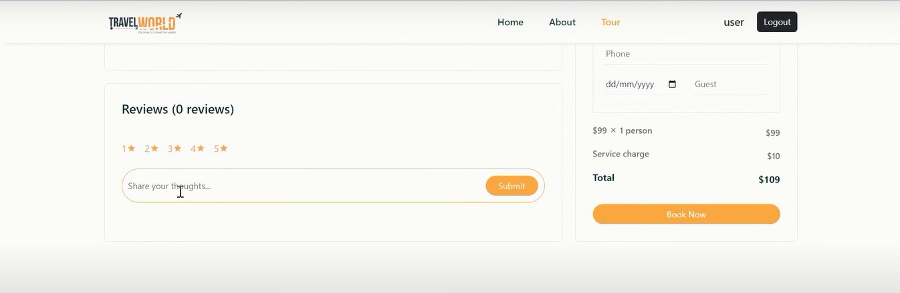

**Conclusion and Future Scope: -**

Tourism is currently recognized as a global industry which is growing at a high rate like any other industry. Access to relevant and accurate information is at the heart of tourism. Here, the proposed project on Tourism Management System tries to bridge the gap by noting what a tourist perceives as relevant.

Hence, the aim of this project entails the design and implementation of a platform that will assist tourists in gaining access to travel to various tourist locations. The project also helped to provide knowledge about the latest technology used in developing web enabled application and client server technology that will be great demand in future.

It is worth mentioning that this project work is open for further enhancement, with the expectation that it becomes more robust and better enhanced; covering every single tourist sites. For a modified system, the user need to just login into the application and can find the routes, costs, hotels, adventure sports, transportations and book immediately and complete the booking process for a successful transaction.

In the aspect of tourism, Internet and web technologies have made more readily available information on tourist locations, accommodations, transportation, shopping, food, festivals, and other attractions, thus improving the whole tourism experience.

**REFERENCE: -**

*Code uploaded at: -* [*https://github.com/soumya3969*](https://github.com/soumya3969)

*Website live link: - Not Deployed yet*

*External Resource from Google.*

**Thank You**